user's manual

Here is an example for the whole manual:

You got a fluorescent microscope data, which contain images of 5 microscopic fields (xy), with 3 channel(c) BF(1),GFP(2) and RFP(3), and capture pictures every 2min for 200 rounds (t). For every microscopic fields you make a z stack (z) of 11 layers. You name your data “Test”

1. The software

Download "window.rar" and decompress it in wherever you want. Run "main.exe" then you can open the window like this. The window is semitransparent and always on the top of all other windows. I make this design because you can easily working with this software when you will have to read a large number of images simultaneous. Dragging the green banner can move the windows around.

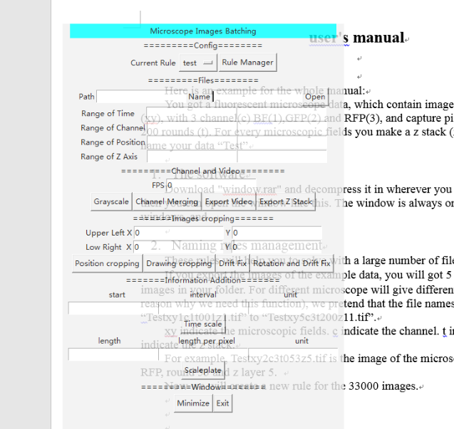

1. Naming rules management

These rules will help you to solve with a large number of file in diverse naming rule.

If you export the images of the example data, you will got 5×3×200×11=33000 images in your folder. For different microscope will give different name (and this is the reason why we need this function), we pretend that the filenames are “Testxy1c1t001z1.tif” to “Testxy5c3t200z11.tif”.

xy indicate the microscopic fields. c indicate the channel. t indicate the time. z indicate the z stack.

For example, Testxy2c3t053z5.tif is the image of the microscopic field 2, channel RFP, round 53 and z layer 5.

Now we will create a new rule for the 33000 images. Click the button “Rule Manager” and you will open a new window.

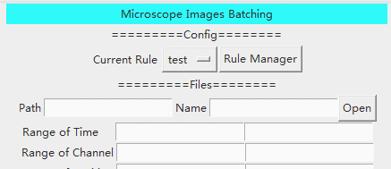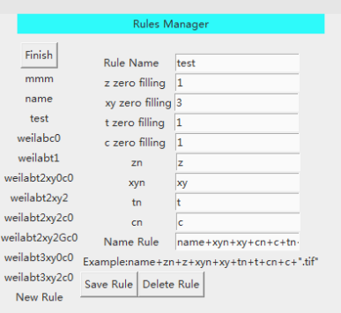

Click “New Rule”, Enter your rule name in order you can find it the next time you need it. Here I Enter “test” for example.

You will find “zn”, “xyn”, “tn”, “cn”, which indicate the tag in the file name. Here we use “z”, “xy”, “t”, “c” for example because the names of our files.

Zero filling will fill the number with 0 untill the given length. For example the number 1, 2, 3…15, 16 have no zero filling (you enter 0 or 1 here), while the number 01, 02, 03…15, 16 have a 2-digit zero filling( you enter 2 here).

Now we look at our example datas. xy(1 to 5), c(1 to 3) and z(1 to 11) are all need no zero fill and t(001 to 200) need 3-digit zero filling.

Then we will enter the rule: name+xyn+xy+cn+c+tn+t+zn+z+".tif"

“zn”, “xyn”, “tn”, “cn” are exactly what we filled in. “name”, “z”, “xy”, “t”, “c” are the name and number we selected irrelevant to the rule. And if you need to add other strings in the rule, use quotation mark to mark it, just like we will need to add the file suffix “.tif”. Then using “+” to join all the elements together.

Then click “Save Rule”, the rule will be creat. A file that record that rule also be created in the folder “rules” in where you decompress the software. Just share this file, you can share your rules with others.

1. Choose your files

First, select the rule you create just now.

Then you can enter the path or name, or you can just “open” it. Of course you will need to modify the name because that is not the real filename. Fill the name with “Test” for example.

Now we pretend you want to turn the image of all the GFP channel of the layer 7 of z stack to gray. This means t will be ranged from 1 to 200, xy will be ranged from 1 to 5, c will be range from 2 to 2, z will be range from 7 to 7. Fill the ranges as below:

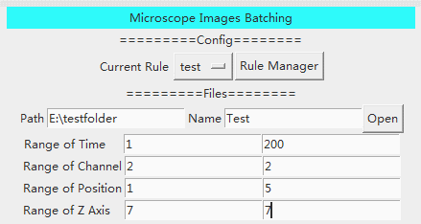

If your filenames don’t include one or more ranges in them, you will also need to fill it, because the software will read all the 4 ranges. You can just fill the blank with the same number, from 1 to 1 for example, which means that the process will run once because the software will loop in the range from 1 to 1. If you fill in from 1 to 2, the process will run twice.

1. Grayscale and Channel Merging

Now we have chosen the files, click Grayscale and you will find the gray images in the same folder.

Note: Processing of such large files will need a long time. You will find the button is in the stage of pressed, just wait and don’t quit the software. It will give a message if it finish its work.

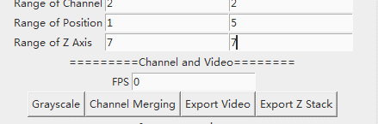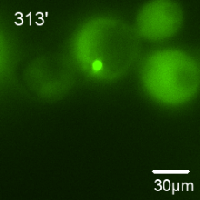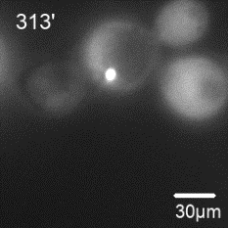

Then we pretend you want to merge all the GFP and RFP channels of the images. The channel range need to be from 2(GFP) to 3(RFP). Filling the ranges as below and click “Channel Merging”.

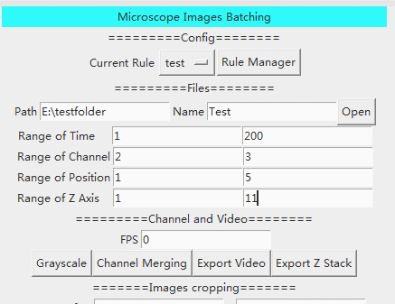

Then you will find the merged images in the same folder.

E:\PKU\iGEM\SynologyDrive\iGEM2018\images\software\MergeG.tifE:\PKU\iGEM\SynologyDrive\iGEM2018\images\software\MergeR.tif G:\images\DOX_drift\20180823doxt155xy1.tif

1. Video and Z Stack

Some time we will need to export videos (of course in time sequence), the software can export the images as avi movies via time. For example, you should fill the time range from 1 to 200 if you want to export full-length video of our example data. I assume that you have known how to fill in the other ranges after learning preamble.

You will need to set a PFS (frame per second) for your video. Then click “Export Video” and you will find videos in the same folder.

And you might need to export z stack video in order to see the structure. Just fill the “Range of Z Axis” with the z stack range you need and click “Export Z Stack”, you will find videos in the same folder.

1. Cropping

To meet the need of difference cropping processing, I provide two method to crop the images.

If you know exactly the position of cropping, you can enter the position of upper left and low right of the cropping region. Then click “Position Cropping”, you will crop the images. For example, you want to crop the images into a 255×255 quadrate. You can enter the position as below:

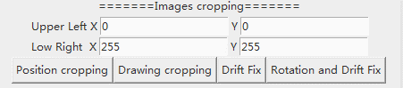

You can also crop the images by drawing the region. Click “Drawing Cropping” and the first images will show. Then draw the region with your mouse till you are satisfied with the region. Press “Enter” of the keyboard, the images will be crop.

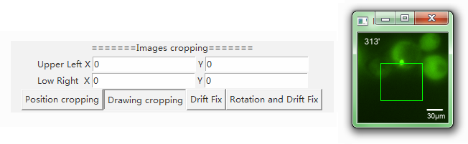

1. Drift Fix and Rotation Fix

If your cells are float in the microscopic field, it can be much annoying. Never mind, this function can help you. “Drift fix” will move the crop region as the cell drift to fix the drift of cell.

Click “Drift Fix”, the first image will show first, now you can draw the region you need to crop and press “Enter” to confirm the region.

Note: You can draw it larger so the cell will not move out of the region, but not too large, if the crop region get out of the images in the process, the cropping will be aborted and the file may be damage. Do this with backup in case the files damaged.

Then, the second windows will show the first image. Click on the image to mark a reference point, press “Enter”. The third window will show the last image. Click on the position where the reference point move into, press “Enter”. The software will fix the drift via the movement of the reference point. In the images below, we can see the same position in the cell moving from the white arrow to the red arrow. You can see the Fixxing results in <http://2018.igem.org/Team:Peking/Software>

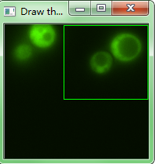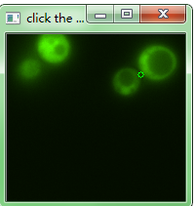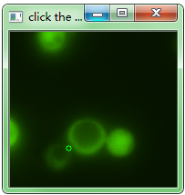

If your cells are rotating, we can also fix it.

Click “Rotation and Drift Fix”, the first image will show first, now you can draw the region you need to crop and press “Enter” to confirm the region.Then, the second windows will show the first image. Draw a line from the rotation center as a reference line, press “Enter”. The third window will show the last image. Draw a line from the moved rotation center to where the reference line move into, press “Enter”. The software will fix the drift via the movement of the rotation center and fix the rotation via the angle between the reference lines. As shows below the reference line rotates of about 90°. You can see the Fixxing results in <http://2018.igem.org/Team:Peking/Software>

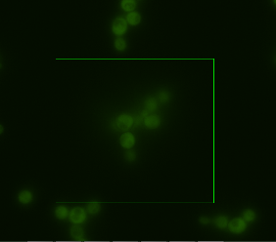 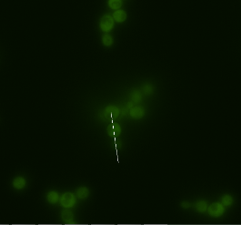 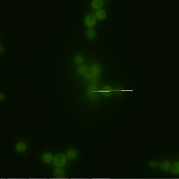

1. Time and Scaleplate

Finally, you want the images in your paper, you will need to add the information like time and scaleplate.

It’s easy enough, enter the time you start, the interval, and the unit of time, and click “Time scale”, the first picture will show, you need to click to set the position where you place your information, press “Enter” to confirm.

Adding a scale plate is also easy. Enter the total length of the plate, length per pixel and the unit of length, then click “Scaleplate”, the first picture will show, you need to click to set the position where you place your information, press “Enter” to confirm.

